Basics of IDE disk interfacing

Connections
These are the basic connections you will need to make in order to communicate with the IDE bus. Some of the missed out connections are for things such as DMA transfers, etc.
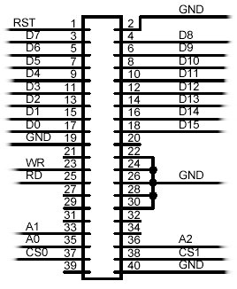
Register Read
Communicating with the IDE bus is made of up a series of registers reads and writes, loading information such as sector numbers into registers, writing commands to the command register, and reading from the data buffer.
The flow chart shows the method of performing a read of a IDE register.
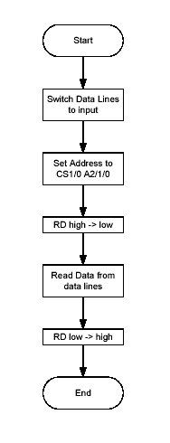
Register Write
The flow chart shows the method of performing a write to a IDE register.
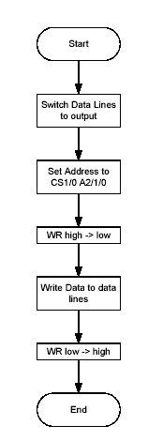
Sector Read
The minimum data transfer from the hard discs media is 512 bytes, which is known as a sector. To perform a sector read, the following is executed;
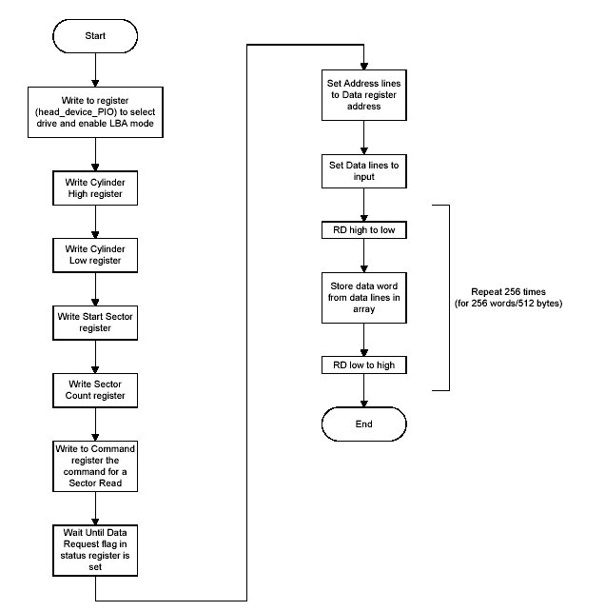
More Information
IDE Command & Register Set - A page on the basic commands and registers used in the ATA standard.

